**Day 3 of the Bioinformatics Internship at Bversity**

**Objective**

The primary goal for Day 3 was to analyze the 2D conformer of a biomolecule using computational tools and visualize its chemical and structural properties. The task involved creating a heatmap as a key output for assessing molecular interactions and properties.

**Workflow and Steps**

1. **Introduction to 2D Conformers**
   * The session began with a theoretical overview of molecular conformations, emphasizing 2D conformers as simplified representations of molecular structures.
   * The importance of 2D conformers in understanding chemical properties and facilitating molecular docking was discussed.
2. **Dataset Selection**
   * Participants were instructed to select a molecule for analysis, either from a provided dataset or using a molecule of their choice.
   * The dataset included structural details like atomic coordinates, bond connectivity, and physicochemical properties.
3. **Software and Tools Setup**
   * The tools introduced included **RDKit** for computational chemistry and
   * Participants ensured their software environment was properly configured, including installing necessary libraries and dependencies.
4. **Generating the 2D Conformer**
   * Using RDKit, the 2D conformer of the molecule was generated:
     + Molecules were read in a standard format (e.g., SDF).
     + RDKit functions were used to interpret molecular structures.
     + Visualization tools displayed the 2D representation.
5. **Heatmap Generation**
   * A heatmap was created to visualize the interaction data:
     + The molecular property matrix was used as input.
     + Library like JFreeChart were utilized to generate the heatmap.
     + A color-coded representation highlighted areas of high and low interaction intensity.
6. **Analysis of the Heatmap**
   * Participants were guided to interpret the heatmap:
     + Regions with higher intensity were correlated to stronger interactions or higher property values.
     + Patterns in the heatmap were used to hypothesize potential binding or functional sites.
7. **Discussion and Troubleshooting**
   * Common errors encountered during the process were addressed, such as:
     + Misalignment of molecular properties in the dataset.
     + Incorrect parameter settings in visualization tools.
   * Solutions included verifying data preprocessing and adjusting visualization parameters.
8. **Practical Applications**
   * Real-world applications of 2D conformer analysis were discussed:
     + Drug design and predicting molecular reactivity.
     + Understanding interactions in biological systems.
9. **Documentation and Reporting**
   * Participants documented their findings:
     + Included the molecular structure, property matrix, heatmap, and analysis.
     + Prepared a detailed report summarizing the workflow, challenges, and outcomes.

**Key Learnings**

* Gained proficiency in using RDKit for molecular analysis.
* Understood the significance of 2D conformers in bioinformatics and drug design.
* Learned to create and interpret heatmaps for visualizing molecular properties.

**Conclusion**

Day 3 provided a comprehensive understanding of 2D conformers and their applications. The session was interactive and hands-on, enabling participants to explore the computational tools effectively and gain insights into molecular properties through heatmaps.

This knowledge lays a strong foundation for advanced topics in molecular modeling and bioinformatics.

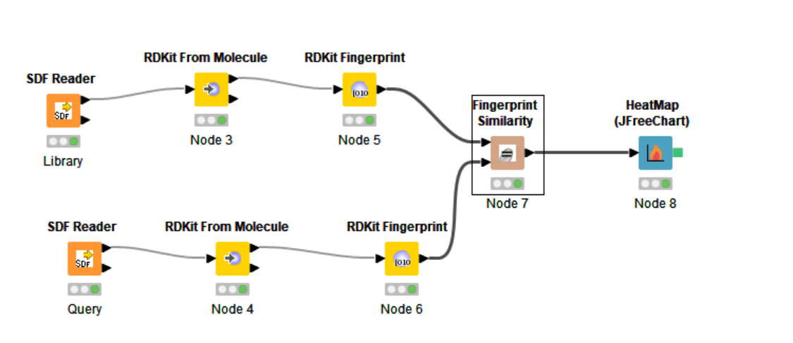 WORKFLOW OF 2D CONFORMER

HEATMAP OBTAINED:

